Hd video USB DISK(mini U8) Manual
(global first paragraph hd U disk storage miniU8 household security high-definition cameras)

First, thanks for your using this product! Please read this manual before using, In order to offer better service, we will change the content of the munual when the product features and functions to be changed. We will not notice again!
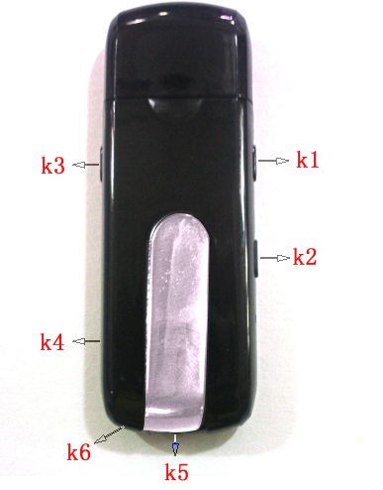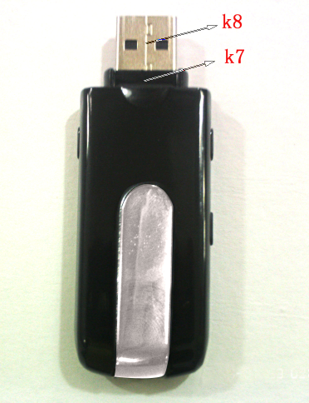
(picture only for reference)

K1: on/off button, Separate recordings key
K2: picture,camera key;
K3: motion detecting camera keys;
K4: State indicator
K5: Scene
K6: MIC
K7: TF CARD
K8: USB port

This is unique design product .It’s rename the "family security miniU8 camera". The product with UBS disk storage, Motion detecting high-definition digital camera, Pictures, Separate recordings, charging and camera, Automatic cycle camera, Memory support 32GB, Connections computer camera directly storage computer function U dish of miniU8 security cameras and TF card memory.
It’s can take photos and high quality monitor, easy and simple to operate, cabinet and delicate, elegant appearance, easy to carry, is the family education and living security, practical tools, essential field subjected to each customer's favour.

Please note before using:
This product internal for precision electronic components composition, operation with light touch ,do not vigorously operation in order to avoid damage the keys,
Use video CAMERA CAMERA (PC) function, please install the random display of the driver.

Keystrokes using explanation: K1. K2 key used to reset, and when the machine is not responding to meet, please also press K1. K2 keys.
K1 key: used for switch machine, separate recordings.
K2 key: used for taking pictures. Camera.
K3 key: used for motion detecting camera.

The operating instructions
Special features of this product: shock prompts can be directly connected to the computer video camera, video camera files can be stored directly on the computer.
Special features: In the state of the network camera (note 6) Click on the driver disk file（debut），Set the location of stored video files，Select（webcam），
Click（确定）Back to start operation of camera。

1, on/off: long press boot key K1, blue and red double light, at the same time machine shake, shake stop, initialization after blue shut off . Red lights keep lighting, enter standby at boot condition, long press K1 keys, machine shake and red light flash 3 times shutdown.
2, taking photo operation: in standby mode, the short press K2 keys, blue light red lights out and began to be photographed and preservation, finish clap as machine shake once and blue lights keep off , red light keep on, re-enter standby.
3, camera operation: in standby mode, the long press K2 keys, machine shake twice, the red light will keep off after three times flashing, photographing and short press K1 or K3 keys, the red lights will keep off after 6 times flashing;the product keep camera state. When camering, short press K2 key ,machine shake once, stop camera and save, meanwhile the red light up into the standby.
4, Separate recording operation: in standby. Short press K1 keys, machine shake once and red light off, blue lights flashing out three times after quench, it’s recording status, then short press K1 keys, machine shake once, save the recording and blue lights off are red light up and into the standby.
5, motion detecting videotape: on standby mode, the short press K3 , machine shake three times ,blue and red light up 4 times and off, into motion detecting camera standby mode, the front have the object was moving, and blue flash into motion detecting camera status, short press K3 , machine shake once, stop motion detecting video and save automatically and then into the standby. The motion detecting camera condition, short press K1 or K2 keys, red and blue light flashing 6 times out, simultaneously has instructed in this condition.
6, PC CAMERA: in shutdown condition, press K2 till put into the PC connected computers, CAMERA.
7, charge: connect the computer USB port or charger, the camera is charging when the battery in charging status, blue lights flashing, when a full battery, blue light off.
Note: the camera built-in high-capacity polymer lithium battery, no memory effect, can charge any time when you use, but before 5 times, please put a battery recharging after you use to activate cells to saturated maximum capacity, obtain the standard working hours.
8Charging Camera: charging, blue light state, press and K3 pause button for 6 seconds, continue to press the K3 key for one second pause, the red light to enter standby mode, then you can take pictures, video, sound recording, motion detection camera.n.

9, set picture recording time: video files show video time function, format for: the year - month - date: hour: minuters:seconds, set a time method as below:
Check if USB cable connect with computer is ok, and then my computer appear "moveable hard disk" picture. Open the Windows software attached tablet or notepad (*. TXT format) input:
[date]
2010/05/05
12:59:30
Take a filename: time.txt
save the file and put into moveable hard disk, cut off the USB cable to connect, open video, the time on the lower-right is the newly revised the time and date. Also can use this machine of stored WriteTime. exe file to update the video time, method for double-click WriteTime.exe in jumped out to update window update and then update
10. Exception handling:
Video camera batterries power not eough, the green light flashing about 3 seconds, automatically saves the current image file and shutdown, if continue to use the camera, please charge after use.
The camera for accidental faulty operation or other special reasons to stop response, and press K1 and K2 ,then restarting before using.
Cannot switch on: the battery power off or not, please charge, At the same time press K1 and (2), shut off the power and restarting.
Cannot connect computer: please confirm your operating system, driver, USB interface, connections is okay. Disk space have enough capacity or not, TF card is inserted well or damaged.

Item | relevant parameter
video format | AVI
video coding | M-JPEG
resolution ratio | 1280*960 1280*720 720*480 640*480 VGA
frame rate | 30fps
play software | The operating system come with or video playback software mainstream
picture format | JPG 1280*1024
image | 5M pix
Image ratio | 4:3
support system | Windows me/2000 xp 2003/vista:M
battery capacity | 300mAh
working hours | About 120 minuters
charging voltage | DC-5V
interface type | MINI 4pin USB
Memory card | micro TF card
battery type | High capacity Polymer lithium electricity

12. The matters needing attention
● set use scene: please strictly abide by relevant state laws, shall not disclose such products used for any illegal purposes, otherwise the consequences is responsible by yourself.
-  about battery: long time using, battery time shorten, long time no use, please prior to the use of full of electricity.
-  player actual capacity is slightly less than the nominal capacity, is a normal phenomenon.
-  files safe: this product non-professional storage devices, are not assurance internal storage file integrity and security, please immediately on a computer or other storage device back up your important files.
-  video quality: this product non-professional recording equipment, do not guarantee all video files effect can come up to your expectation.
-  working temperature: 0-40 ℃
-  work humidity: 20% - 80%, do not use products in the damp working environment, the product does not have waterproof function.
-  filming illumination: please in a well-lit dust-free environment, do not please camera directly to the sun such strong illuminant, lest optical device is broken.
-  cleaning requirements: do not excessive dust density under the environment of use, lest lens and other components infected with dust, affect camera lens effect, can be used to wipe lens paper or glasses cloth wipe gently, keep clean.
-  other matters: this product is precision electronic products, please do not make it hit, vibration: do not in strong magnetic field, &high off-court use.
-  waste treatment: please pay attention to environmental protection, not discarded this product and throwing in fire, for preventing explosion.
Additional information: other unmentioned matters please contact with local dealers

